Experiment No. 10

Name:- Iqra Shaikh

Roll no:- 24DCO06

Batch :- 01

AIM :Implementation of RIP Routing Protocol in Cisco Packet Tracer

What is RIP Protocol?
RIP (Routing Information Protocol) is a distance-vector routing protocol used in small to medium-sized networks. It uses hop count as the metric to determine the best path and allows a maximum of 15 hops.

Advantages
- Simple to configure and manage
- Automatically updates routing tables through neighbor routers
- Suitable for small networks and lab simulations

Disadvantages
- Slow convergence compared to modern protocols
- Limited to 15 hops, not suitable for large networks
- Does not support advanced features like authentication or VLSM (in RIP v1)

Network Topology (Similar to Provided Structure)
PC0 ↔ Switch0 ↔ Router0 ↔ Router1 ↔ Switch1 ↔ PC1

Testing Connectivity
- Go to PC0 → Command Prompt
- ping 192.168.2.10

Steps to Install Cisco Packet Tracer
- Visit the Cisco NetAcad website.
- Create or log in to your account.
- Download Cisco Packet Tracer for your operating system.
- Install and launch the software.

Steps to Configure RIP Protocol in Cisco Packet Tracer
- Open Cisco Packet Tracer.
- Drag and place the following devices:
  - 2 Routers (Router0 and Router1)
  - 2 Switches (Switch0 and Switch1)
  - 2 PCs (PC0 and PC1)
- Connect the devices:
  - PC0 → Switch0 (Copper Straight-Through)
  - Switch0 → Router0 FastEthernet0/0 (Straight-Through)
  - Router0 Serial0/0 → Router1 Serial0/0 (Serial Cable – DCE to DTE)
  - Router1 FastEthernet0/0 → Switch1 (Straight-Through)
  - Switch1 → PC1 (Straight-Through)
- Assign IP addresses to PCs:
  - PC0: 192.168.1.10 / 255.255.255.0
  - PC1: 192.168.2.10 / 255.255.255.0
- Configure IP addresses on Router0:
  - FastEthernet0/0 → 192.168.1.1 / 255.255.255.0
  - Serial0/0 → 10.0.0.1 / 255.255.255.252
- Configure IP addresses on Router1:
  - FastEthernet0/0 → 192.168.2.1 / 255.255.255.0
  - Serial0/0 → 10.0.0.2 / 255.255.255.252
- Enable RIP on Router0:
  - Enter router configuration mode
  - Use command: router rip
  - Use version 2
  - Add networks:
  - network 192.168.1.0
  - network 10.0.0.0
- Enable RIP on Router1:
  - Enter router configuration mode
  - Use command: router rip
  - Use version 2
  - Add networks:
    - network 192.168.2.0
    - network 10.0.0.0
- Test communication:
  - From PC0, open Command Prompt
  - Type: ping 192.168.2.10
  - If replies are received, RIP is working correctly.
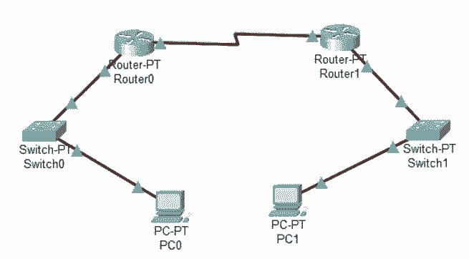

Conclusion
The RIP protocol allows routers to automatically share routing information using hop count as the metric. It is easy to configure and ideal for basic routing simulations in Cisco Packet Tracer. Although it lacks scalability, it provides a solid foundation for understanding dynamic routing concepts.

